State Pattern

* When you need to implement a method based on the state of an object at runtime

UML Diagram of Vending Machine in State Pattern

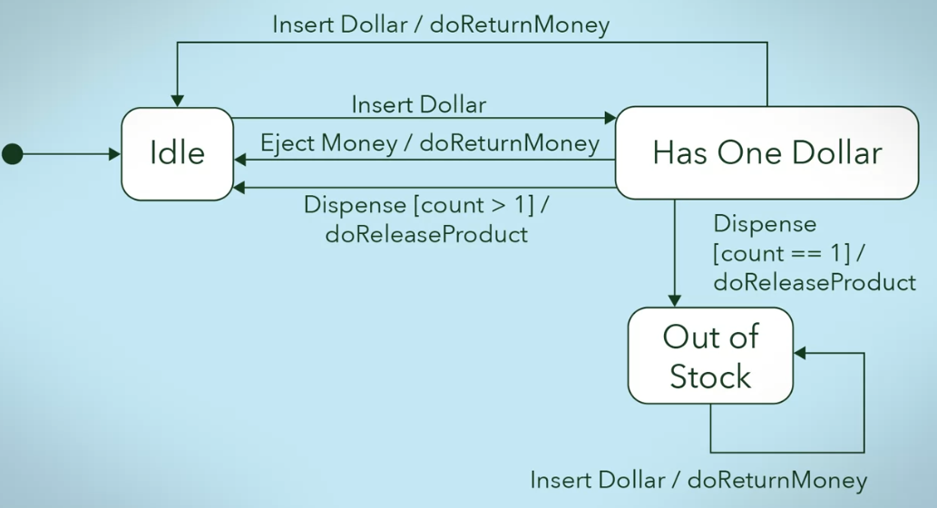

* States
  + Idle
  + Has one dollar
  + Out of stock
* Triggers/Events
  + Insert dollar
  + Eject money
  + Dispense
* Action
  + doReturnMoney
  + doReleaseProduct

Java Code for Vending Machine

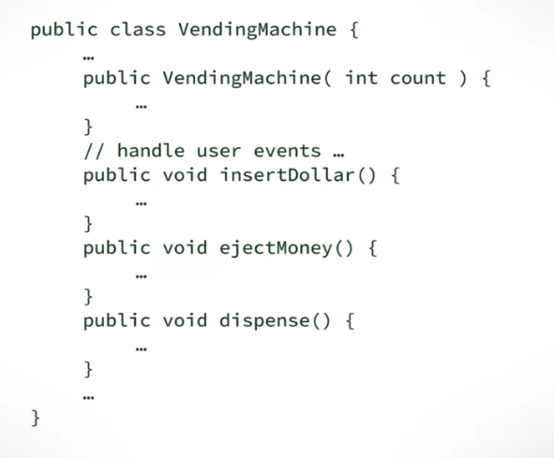

Implementing State using Singleton Pattern

Disadvantage: long conditionals!

1. Define a singleton object for the states

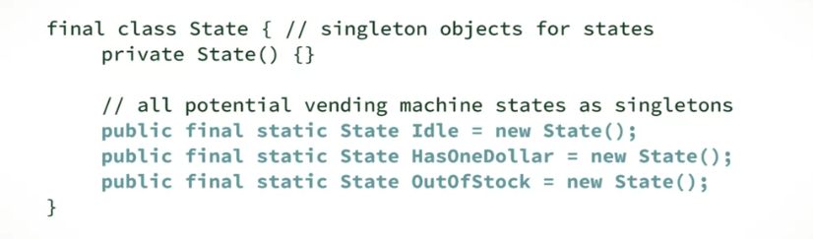

1. Implement in the VendingMachine Class

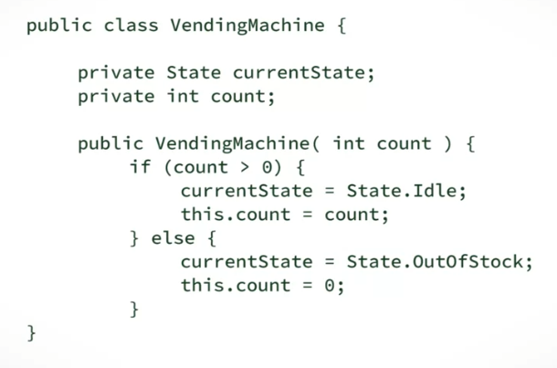

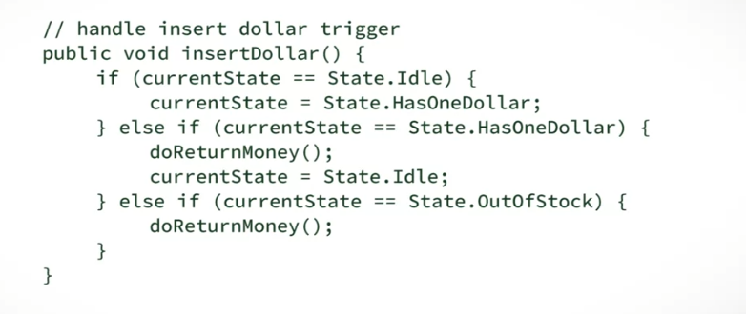

Restructuring using State Pattern

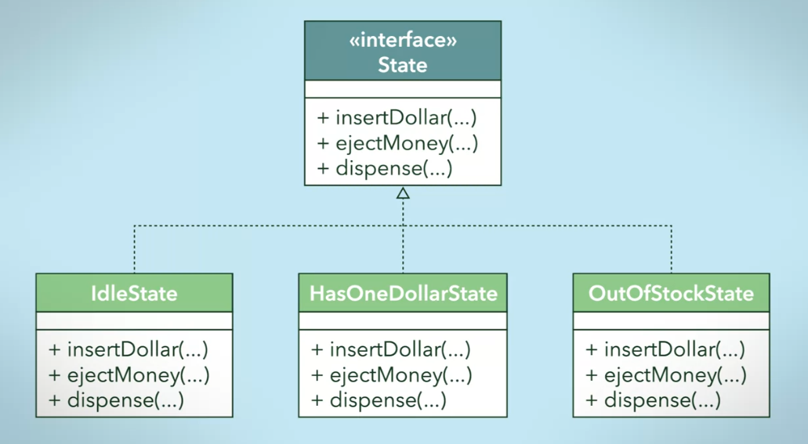

1. Create interface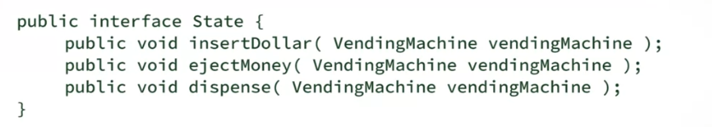
2. Implement in subclass

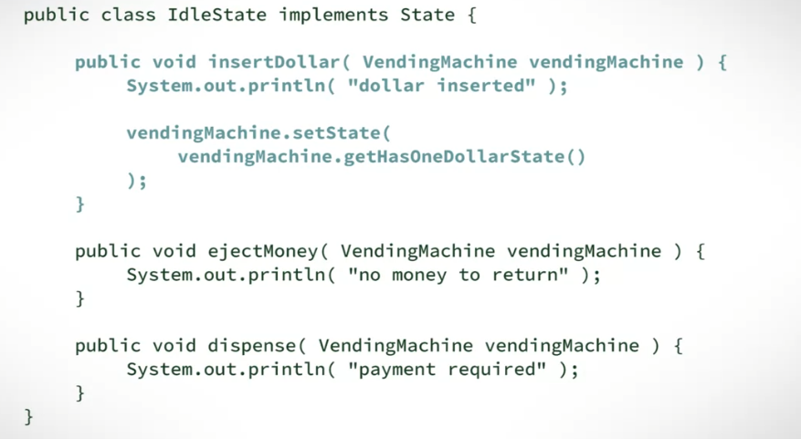

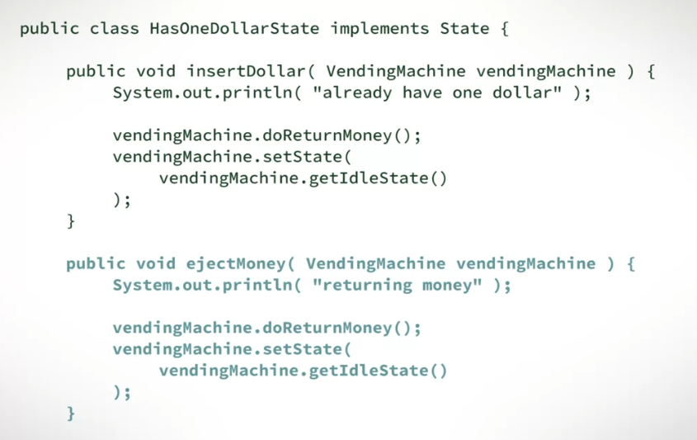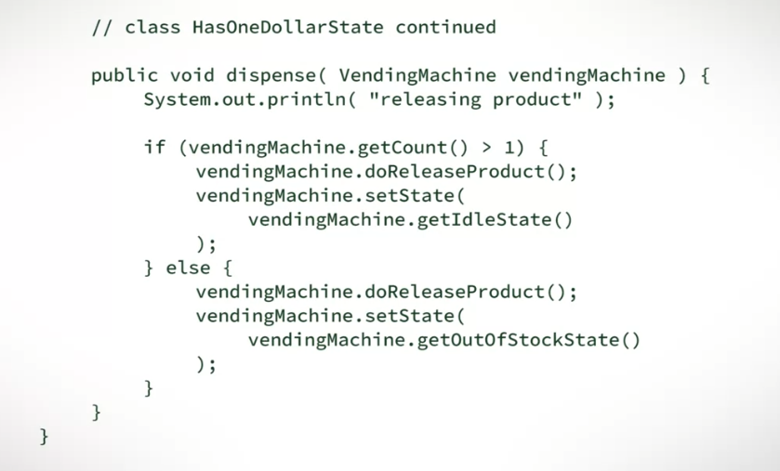

1. Instantiate in the superclass

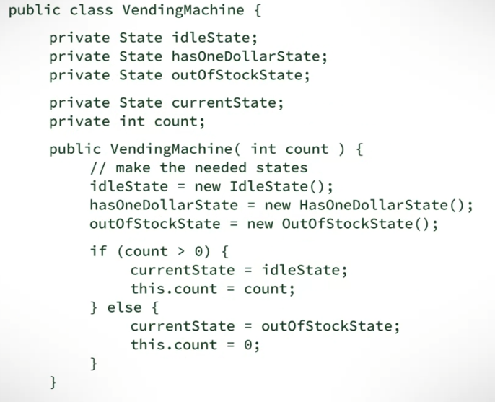

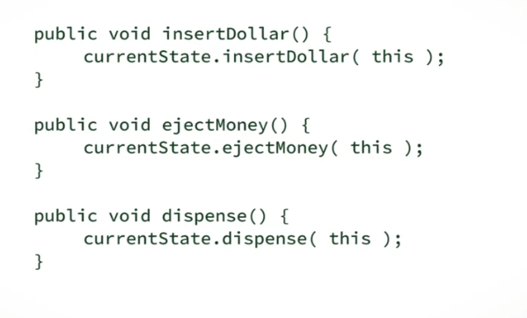

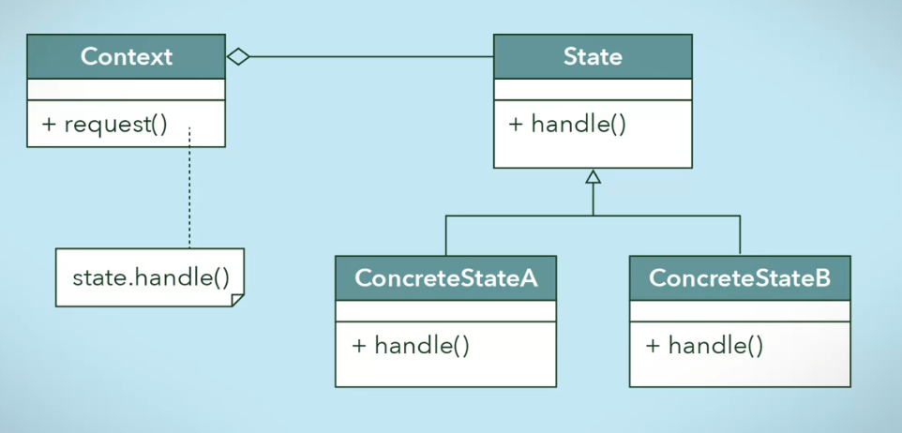

* Pwede to sa Specifications!